**CHATBOT DEPLOYMENT WITH IBM CLOUD WATSON ASSISTANT-BUILD A PROJECT**

|  |  |
| --- | --- |
| **Date** | **31-10-2023** |
| **Team ID** | **676** |
| **Project Name** | **Chatbot Deployment with IBM Watson Assistant** |

**Introduction**

In today's fast-faced digital world, businesses and organizations are constantly seeking innovative ways to engage with their audience, provide quick access to information, and enhance customer experiences. One such solution is the creation of a helpful virtual guide using IBM Cloud Watson Assistant. This virtual guide can be customized to assist users on popular messaging platforms like Facebook Messenger and Slack, offering a friendly and informative conversational experience.

**Problem Statement**

Create a helpful virtual guide using IBM Cloud Watson Assistant. Customize the chatbot to assist users on popular messaging platforms like Facebook Messenger and Slack. Provide useful information, answer FAQs, and offer a friendly conversational experience. Empower users with quick access to information and create meaningful connections through your virtual guide.

**Literature Survey**

**Conversation-Driven Approach for Chatbot Management – G.A.Santos et al [2022]**

The object identifier corresponds to a specific research paper titled “A Conversation-Driven Approach for Chatbot Management.” In this study, the authors present an innovative approach to managing chatbots, emphasizing a conversation driven methodology. They likely propose methods or techniques for optimizing chatbot interactions, improving user experiences, and enhancing the overall performance of chatbots. Such research contributes to the field of chatbot development and management, aiming to make these AI-driven conversational agents more effective and user-friendly. Please note that to access the full details and findings of this research paper, you would need access to the IEEE Xplore Digital Library or the source where it’s published.

**A Literature Survey of Recent Advances in Chatbot-Sardar Jaf [2022]**

A literature survey of recent advances in chatbots is an examination of academic research and developments in the field of chatbots. This survey typically summarizes and analyzes various studies, papers, and articles published in recent years, highlighting advancements in chatbot technology. It may cover topics such as improved natural language processing capabilities, integration with machine learning and AI techniques, enhanced user experiences, and applications in various domains like customer service, healthcare, and education. Such surveys serve as valuable resources for understanding the current state of chatbot technology and identifying trends and areas of innovation in this rapidly evolving field.A Literature Survey of Recent Advances in Chatbots.

**Xatkit: A Multimodal Low-Code Chatbot Development Framework – G.Daniel et al [2020]**

A Multimodal Low-Code Chatbot Development Framework is a comprehensive platform that simplifies the creation of chatbots capable of understanding and responding to various forms of communication, including text, voice, and images. This framework offers a user-friendly interface with pre-built components and automation tools, enabling developers to create versatile chatbots efficiently, reducing the need for extensive coding. It enhances the user experience by allowing seamless interactions through different modalities, make valuable resource for businesses and developers seeking to build advanced chatbot applications.

**Intelligent Chatbot for Prediction and Management of Stress-Tushar Sharma [2021]**

An intelligent chatbot for the prediction and management of stress is an AI-driven virtual assistant designed to assist individuals in identifying, coping with, and managing stress related issues. This chatbot employs advanced algorithms and natural language processing to engage users in conversations, assess their stress levels through dialogue and data analysis, and offer personalized recommendations and strategies to alleviate stress. It can provide insights, suggest relaxation techniques, recommend resources, and even track users' progress over time. This innovative tool aims to promote mental well-being by leveraging technology to address and mitigate stress, ultimately improving users' quality of life.

**Chatbot using AWS -Gowtham[2021]**

A chatbot using AWS refers to a conversational agent or virtual assistant that is hosted and powered by Amazon Web Services (AWS) cloud infrastructure. AWS offers a range of services and tools that developers and businesses can leverage to create, deploy, and manage chatbots effectively. These chatbots can be integrated into websites, applications, or messaging platforms to provide automated interactions with users. AWS services like Amazon Lex and Amazon Polly may be utilized for natural language understanding and speech synthesis, respectively, enhancing the chatbot's capabilities. This approach allows for scalability, security, and reliability, making it a popular choice for businesses and developers looking to implement chatbot solutions.

**Design Thinking**

# **Empathize:**

# The problem at hand is the absence of an efficient and user-friendly virtual guide on widely used messaging platforms like Facebook Messenger and Slack. Businesses and organizations struggle to deliver prompt responses to user inquiries and FAQs, leading to user frustration and missed engagement opportunities. There is a pressing need for a cost-effective and customizable chatbot solution powered by IBM Cloud Watson Assistant that can provide 24/7 customer support, offer helpful information, and foster meaningful connections, addressing the challenge of delivering timely and personalized assistance across multiple digital channels.

**Actions:**

Choose a Chatbot Platform: Select IBM Cloud Watson Assistant for chatbot development.

Customize the Chatbot: Create a tailored chatbot to handle FAQs and provide business-specific information.

- Integrate and Secure: Configure the chatbot for messaging platforms, ensuring basic data security measures are in place.

**Define:**

Based on our understanding of the problem and the users' needs, we will define clear objectives and success criteria for our project.

**Objectives:**

Enhanced User Engagement: Improve user engagement and satisfaction by providing quick, accurate, and personalized responses to inquiries and FAQs on messaging platforms.

Efficient Support: Streamline customer support operations by deploying a chatbot that can efficiently address common user queries, freeing up human resources for more complex tasks.

**Ideate:**

Interactive User Onboarding: Develop an interactive onboarding process within the chatbot to guide new users through its capabilities and functionalities, making the user experience more intuitive and engaging.

**Actions:**

Design an engaging onboarding conversation flow.Provide informative introductions to the chatbot's capabilities.

Gather and act upon user feedback for ongoing improvements.

**Prototype:**

Develop a functional chatbot prototype using IBM Cloud Watson Assistant that showcases how the chatbot can interact with users on popular messaging platforms, answer frequently asked questions, and provide personalized responses.

**Actions:**

Conduct usability testing with a small group of users to gather feedback on the chatbot's functionality, user interface, and overall user experience.

Refine the chatbot's conversation flows and responses based on the usability testing feedback to improve its effectiveness and user-friendliness.

**Test:**

Conduct a scalability test to evaluate how the chatbot performs under a simulated high-volume of user interactions to ensure it can handle increased traffic without degradation in response times or quality of service.

**Actions:**

Set up a controlled testing environment that can generate a high volume of user interactions concurrently.

- Continuously monitor the chatbot's behavior and performance throughout the test.

Gradually increase the load on the chatbot system beyond its expected capacity to identify its breaking points and potential bottlenecks.

Analyze the test results to pinpoint areas of improvement, such as optimizing database queries, code efficiency, or server resources.

**Implement:**

Deploy the customized chatbot on Facebook Messenger and Slack messaging platforms to enable users to access information, receive assistance, and engage in conversations, enhancing user satisfaction and business communication.

**Actions:**

Create accounts on Facebook Messenger and Slack. Connect the chatbot to these platforms.

Build and deploy the chatbot using IBM Cloud Watson Assistant.

Ensure it works seamlessly on the messaging platforms.

Develop a strategy to attract and inform users about the chatbot.Use messaging campaigns to promote its features and benefits.

**Iterate:**

Continuously gather user feedback and data on chatbot interactions to make regular improvements to its responses, capabilities, and user experience on Facebook Messenger and Slack.

**Actions:**

Encourage users to provide feedback on their interactions with the chatbot through messaging platforms. Create a feedback mechanism that allows users to report issues and suggest improvements.

Regularly analyze user interactions and feedback data to identify common user queries, pain points, and areas for enhancement

Update and refine the chatbot's responses and conversational flows based on the feedback and data analysis.

Ensure that the chatbot's performance and user experience have been enhanced according to user feedback.

**Technology Architecture**

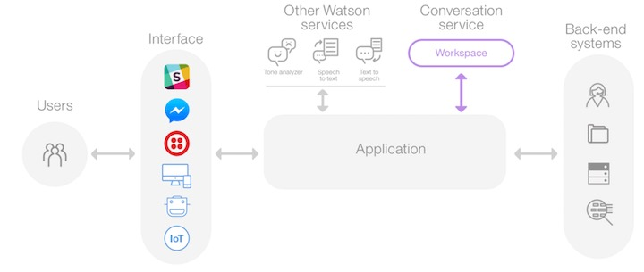

**1.**Watson Assistant Service

The core component is the Watson Assistant service from IBM, which provides natural language processing and conversation management capabilities.

2. Cloud-Based Hosting

The chatbot is hosted on a cloud platform to ensure scalability, reliability, and accessibility from various messaging platforms like Facebook Messenger and Slack.

3. Integration Adapters

Integration adapters or connectors are used to link Watson Assistant with external messaging platforms. These adapters facilitate bidirectional communication, allowing the chatbot to send and receive messages on theseplatforms.

4. Webhooks

Webhooks are employed to handle real-time updates and data transfer between the chatbot and messaging platforms. They enable the chatbot to respond to user messages and events promptly.

5.OAuth for Authentication

OAuth (Open Authorization) is used for secure user authentication and authorization when integrating with platforms like Facebook Messenger and Slack. It ensures the chatbot has the necessary permissions to interact with users on these platforms.

6. Message Formatting

The architecture includes message formatting components to ensure that responses from the chatbot are properly formatted and displayed within the specific user interface of each messaging platform, whether it's Facebook Messenger, Slack, or others.

7. Multi-Channel Support

Beyond Facebook Messenger and Slack, the architecture should be adaptable to integrate with other messaging platforms, providing a seamless and consistent chatbot experience across multiple channels**.**

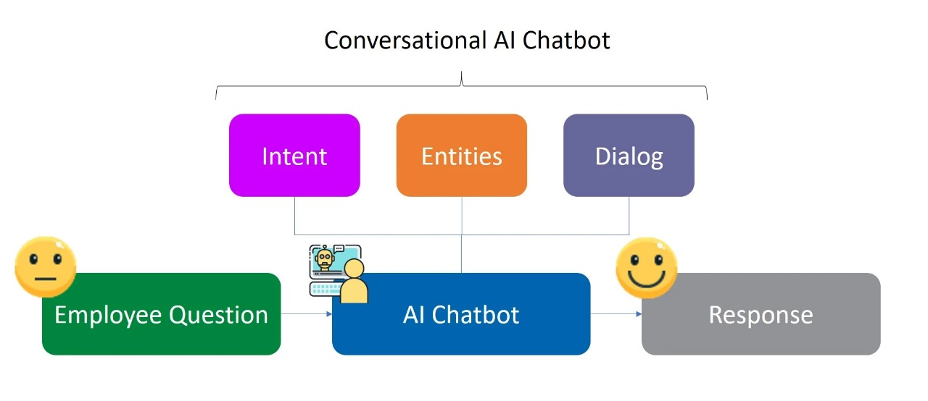

**MODULE DESCRIPTION**

1. Intents:

Objective: Intents represent the goals or purposes of the user when interacting with the chatbot.

Key Tasks: Create and define intents that the chatbot should recognize. These intents help the chatbot understand what users want.

1. Entities:

Objective: Entities are pieces of information within user inputs that are relevant to the intents.

Key Tasks: Define and configure entities to extract specific information from user messages, such as dates, locations, or product names.

1. Dialog Flow:

Objective: The dialog flow determines how the chatbot responds to user inputs based on recognized intents and entities.

Key Tasks: Design a conversation flow, set up responses, and create context variables for dynamic interactions.

1. Integration with Watson Services:

Objective: This module allows integration with other IBM Watson services like Language Translator, Tone Analyzer, etc., to enhance the chatbot's capabilities.

Key Tasks: Configure and connect additional Watson services to analyze and translate text within the chatbot.

1. Webhooks:

Objective: Webhooks enable external services to be triggered based on user interactions.

Key Tasks: Set up webhooks to connect with external systems or APIs for more complex tasks, like retrieving data from a database.

1. User Testing and Training:

Objective: Continuously improve the chatbot's performance through user feedback and retraining.

Key Tasks: Regularly test the chatbot, collect user feedback, and retrain the assistant to make it more accurate and helpful.

1. Deployment and Integration:

Objective: Deploy the chatbot to different channels and integrate it with your applications or websites.

Key Tasks: Deploy the chatbot to web pages, messaging platforms, or mobile apps, and integrate it into your digital ecosystem.

**ALGORITHMS AND TECHNOLOGIES USED**

**1.Natural Language Understanding (NLU):**

Description: NLU algorithms are at the core of chatbot functionality, helping the chatbot understand and interpret user inputs. Watson Assistant utilizes machine learning algorithms to recognize intents and entities within user messages, making it more context-aware.

**2.Dialog Management Algorithms:**

Description: Dialog management algorithms are essential for creating conversational flow. Watson Assistant uses algorithms to determine how the chatbot responds to user inputs based on recognized intents, entities, and context variables.

**3.Webhooks for Integration:**

Description: Webhooks allow chatbots to interact with external services and APIs. When a webhook is triggered, it can connect to external systems using various technologies, such as HTTP requests, and retrieve or send data as needed.

**4.User Testing and Training Tools**:

Description: Watson Assistant offers tools for user testing and retraining the chatbot. It uses machine learning technologies to adapt and improve its performance based on user feedback and new data.

**5.Security and Compliance Features:**

Description: IBM Cloud Watson Assistant includes technologies for data encryption, access control, and compliance checks to ensure the chatbot operates securely and aligns with privacy regulations.

**PROJECT DEVELOPMENT STEPS AND SCREENSHOT**

**Step 1: Account creation and create a new project in IBM Watson Assistant:**

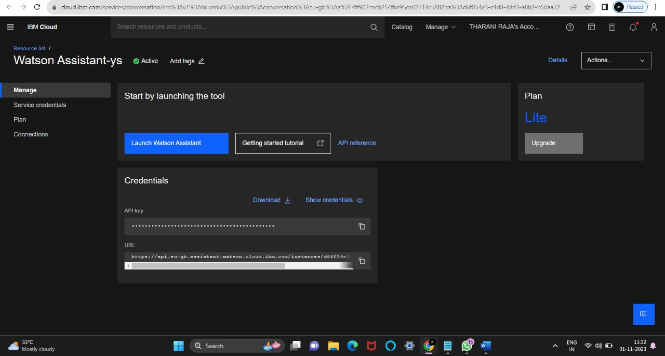

**Step 2: Creation of Intent :**

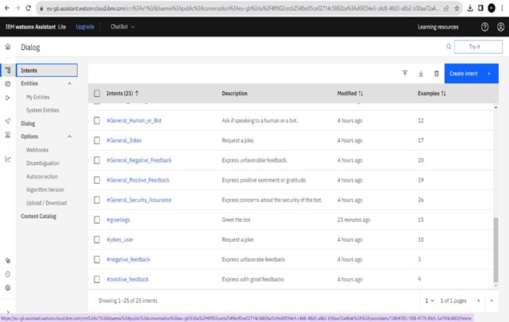

**Add Greetings:**

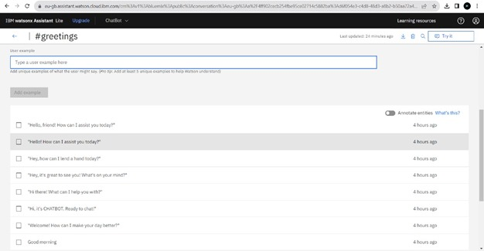

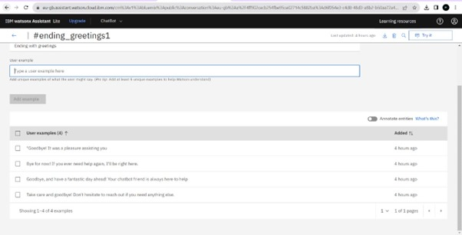

**Step 3: Creation of Entities:**

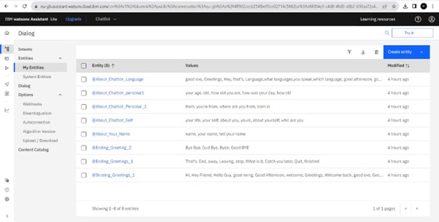

**Starting Greeting:**

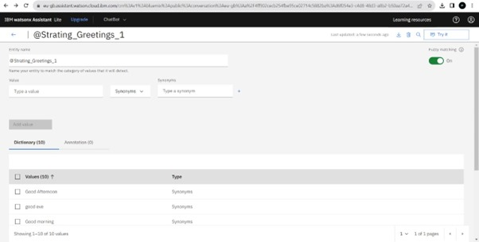

**Ending Greeting:**

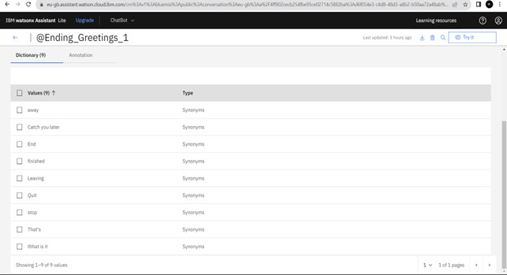

**Step 4: Creation of Dialog Flow:**

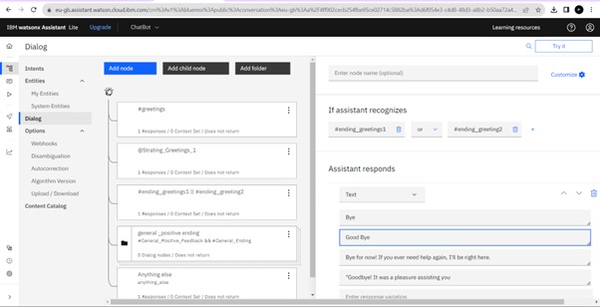

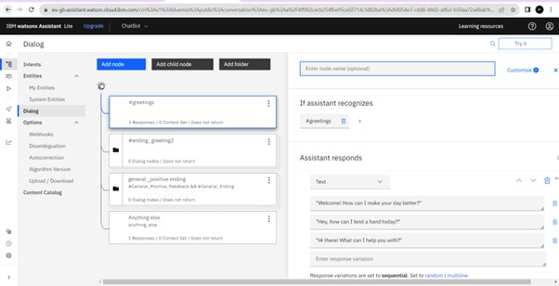

**Step 5: Train the Bot:**

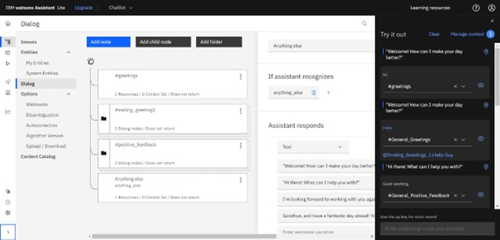

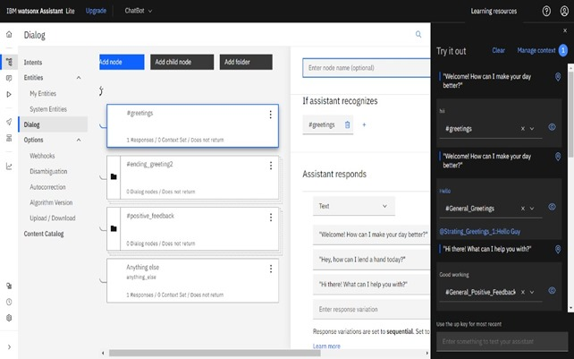

**Step 6:Integrate with Facebook Messenger:**

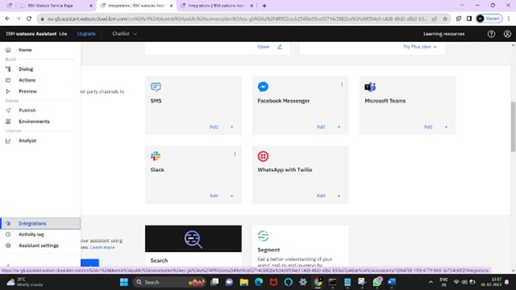

**Add with Facebook Messenger:**

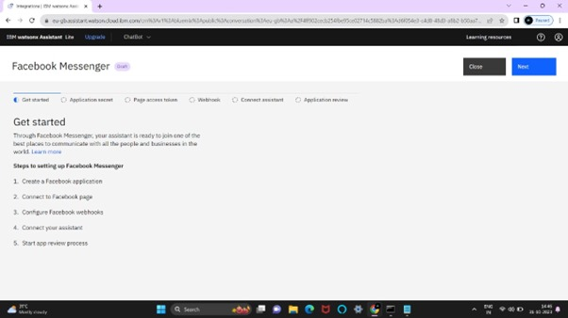

**Create Facebook Application:**

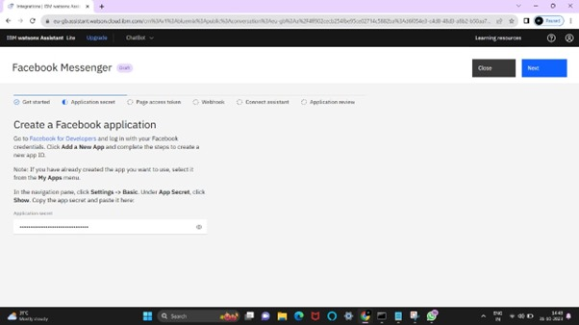

**Connect to Facebook Page:**

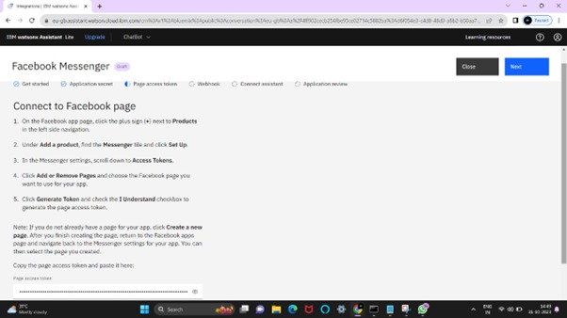

**Connect to Facebook Webhooks:**

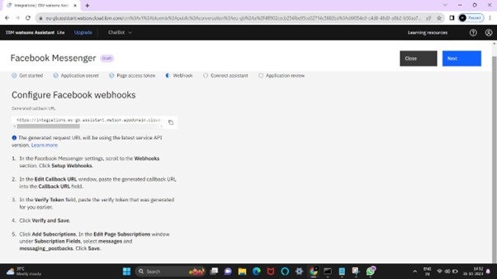

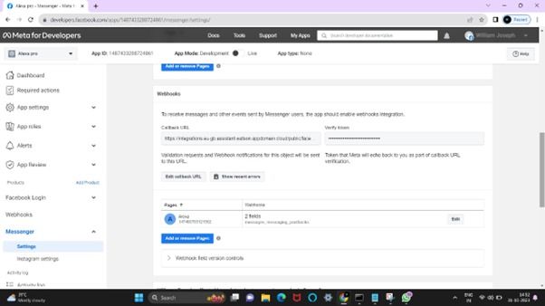

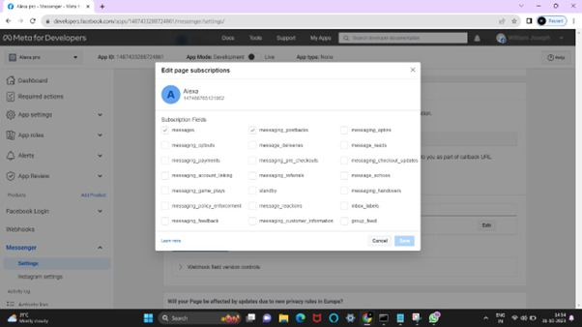

**Step 7:Connect to Assistant:**

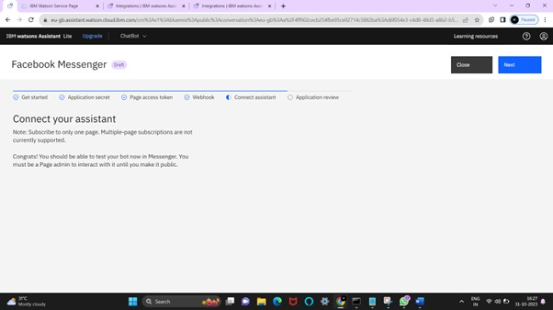

**Step 8: App Review:**

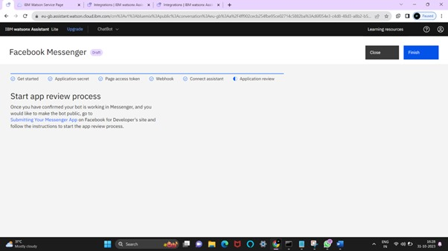

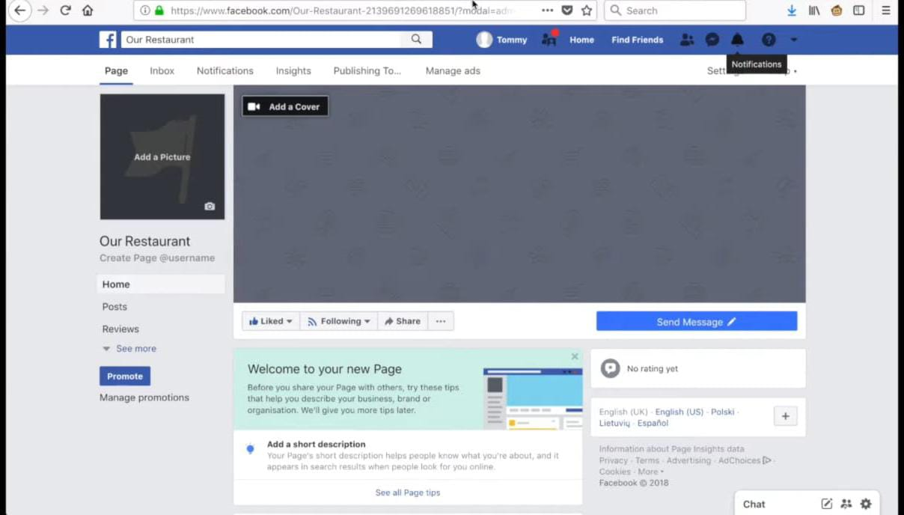

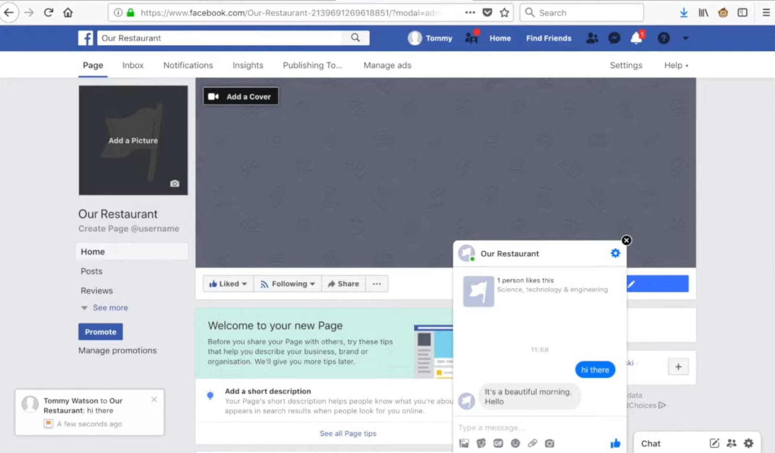

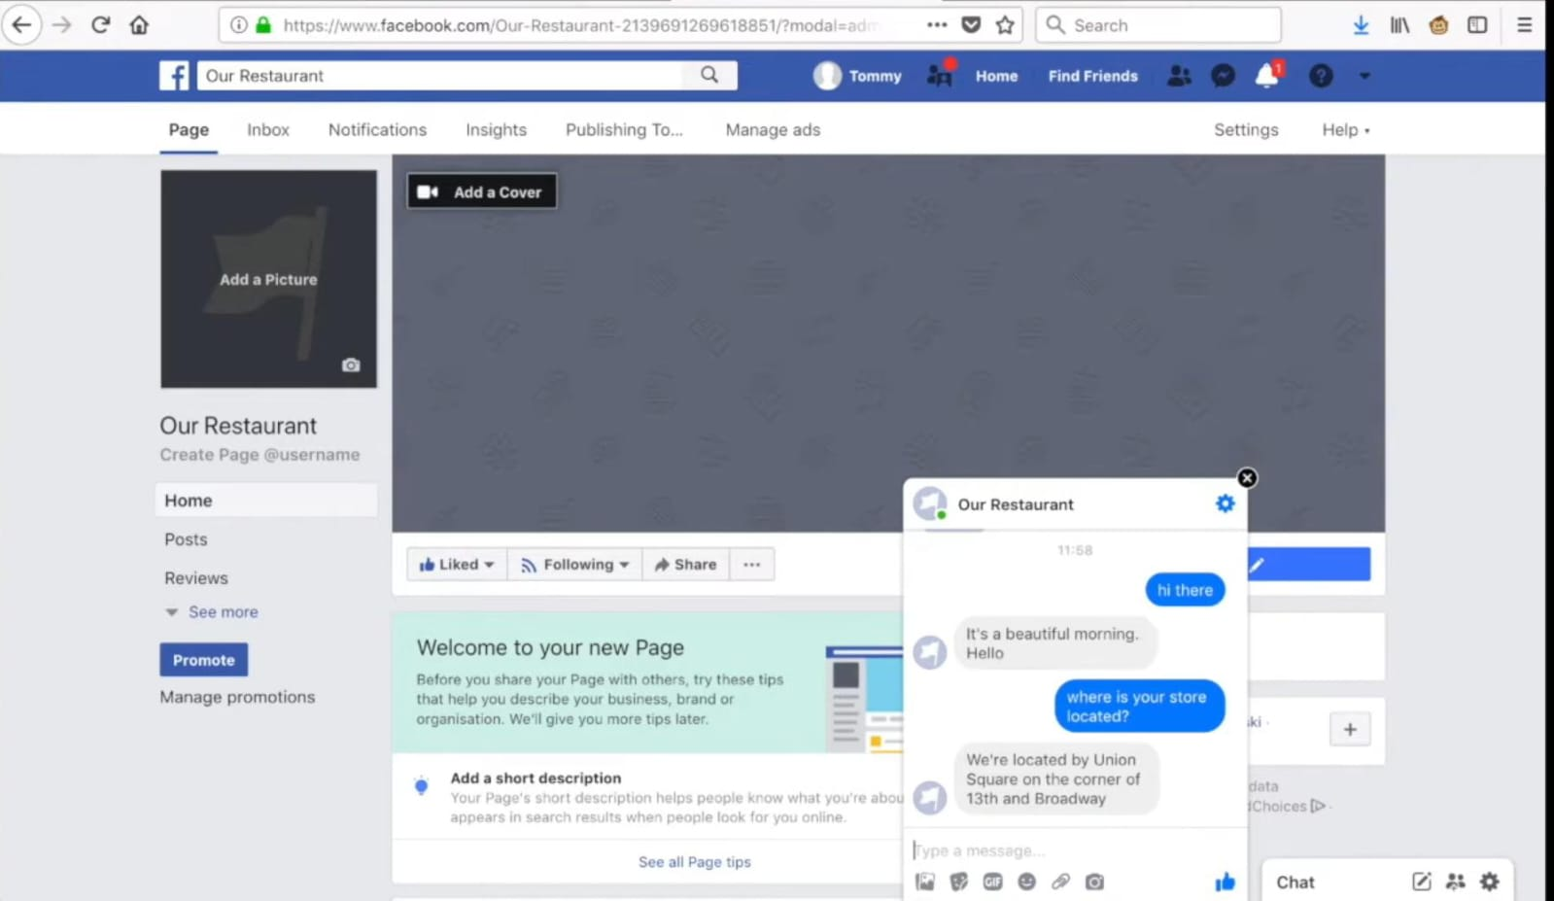

**Conclusion:**

In conclusion, deploying a chatbot using IBM Cloud and integrating it with Watson Assistant offers a powerful and flexible solution for a wide range of project requirements. IBM Cloud Foundry provides a robust platform for hosting applications, ensuring scalability, security, and reliability. Watson Assistant, on the other hand, empowers the chatbot with natural language understanding capabilities, allowing it to interact with users effectively .This combination allows you to create a chatbot that can serve various functions, whether it's customer support, information retrieval, or process automation. Once you have performed the relevant activities and configured the chatbot, you can create a comprehensive document summarizing the project's architecture, deployment, and capabilities. This document will be invaluable for assessment, showcasing how IBM Cloud and Watson Assistant were leveraged to build a chatbot that meets the project's specific requirements effectively.And you must be able to test your bot now in Messenger.